1. Download Postman
2. Create an account
3. Create a collection - “Homework”
4. Add new request - GET method
5. Set your HTTP request to GET
6. Get a response, check the status code (200OK) and response body

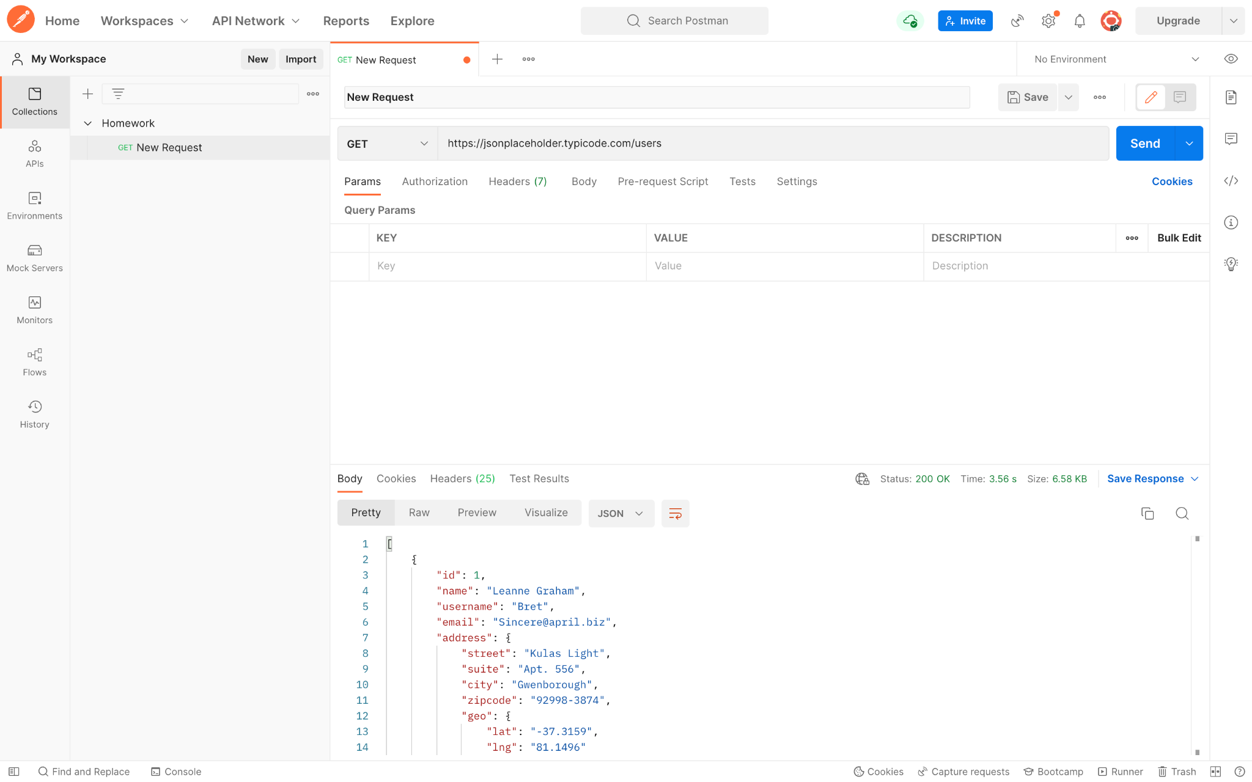

1. Create New Request - POST
2. Choose Body → raw → JSON
3. Add Body and change id to “11” and name to “NatalieG”
4. Save → Send → add the request → Status code - 201 Created

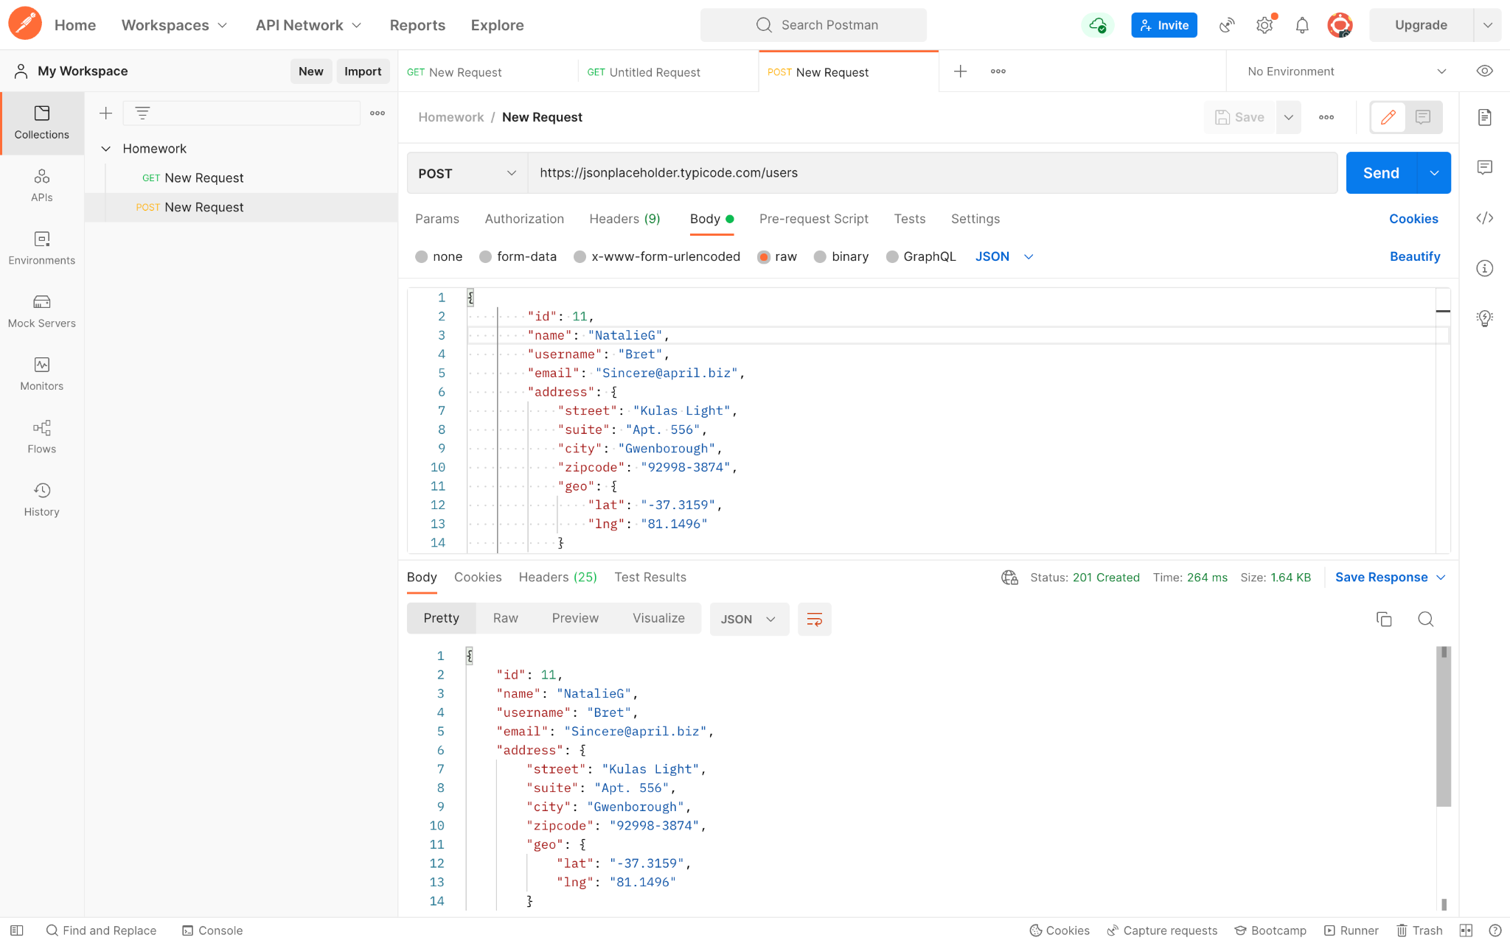

1. Create the URL - parameter
2. Check if the request works correctly with {{url}} parameter

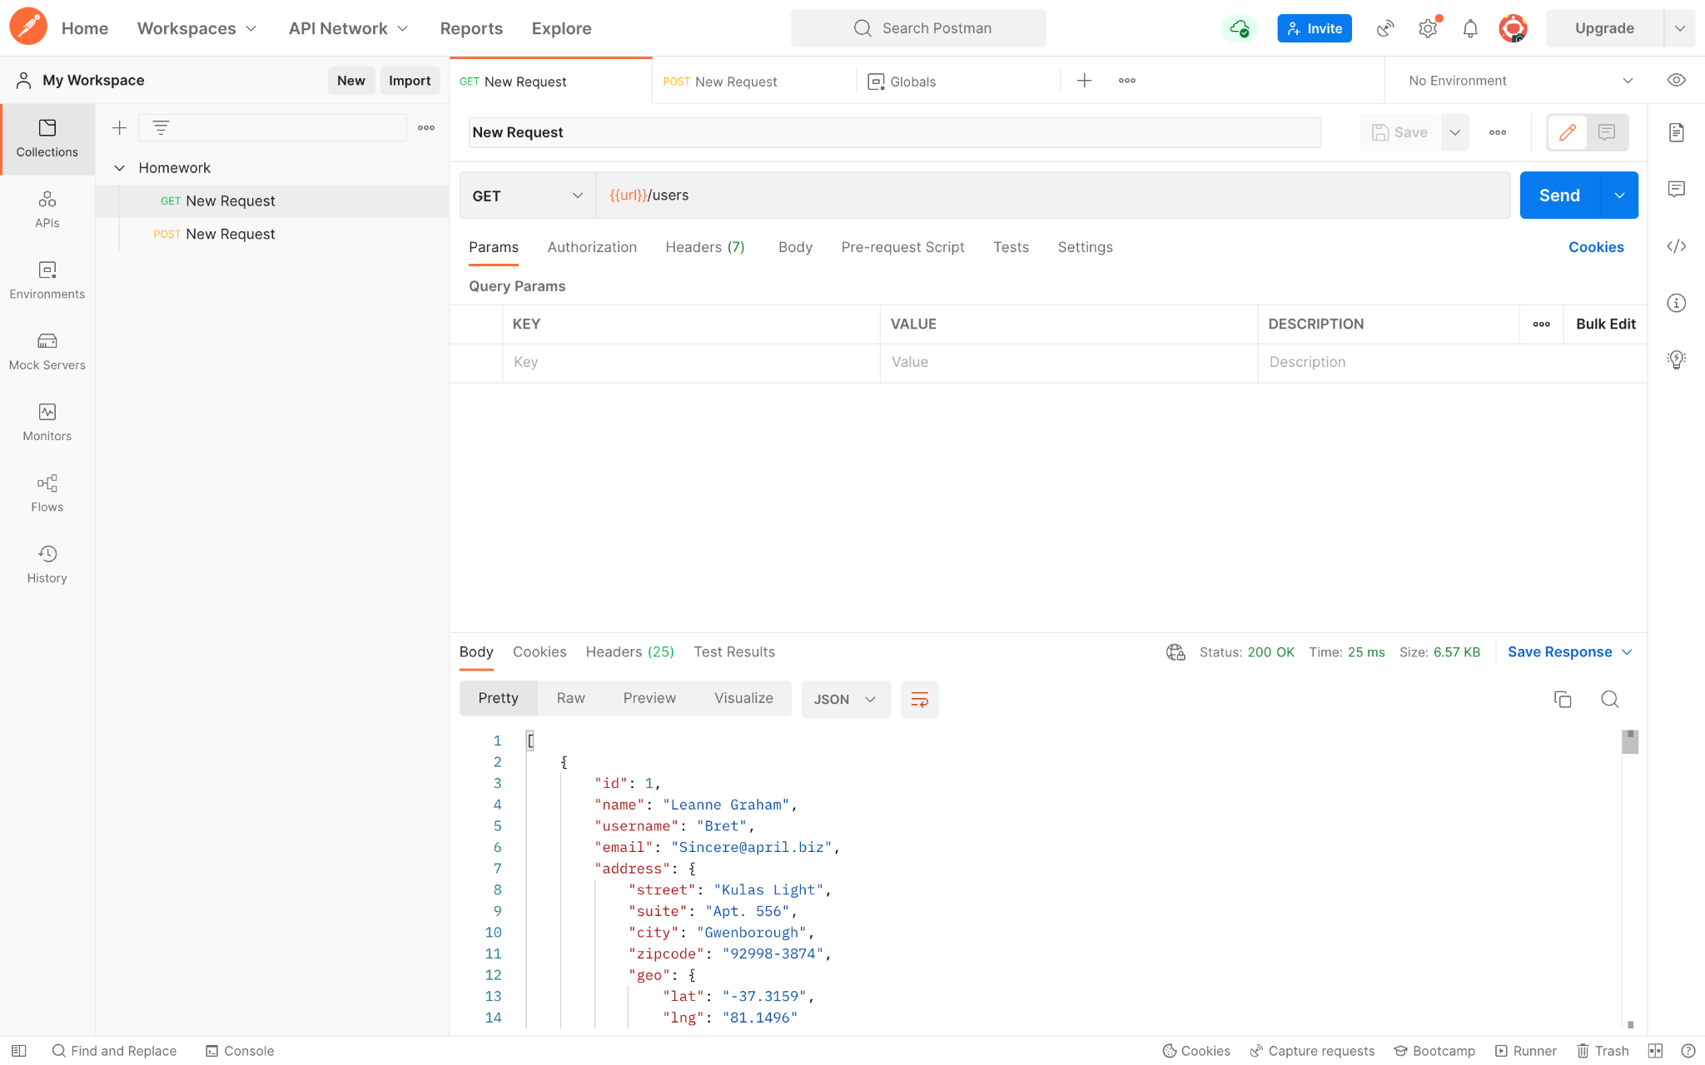

1. Go to the “Test” tab
2. Choose test in Snippets (“Status code is 200”)
3. Send the request and check Test Results (“Pass”)

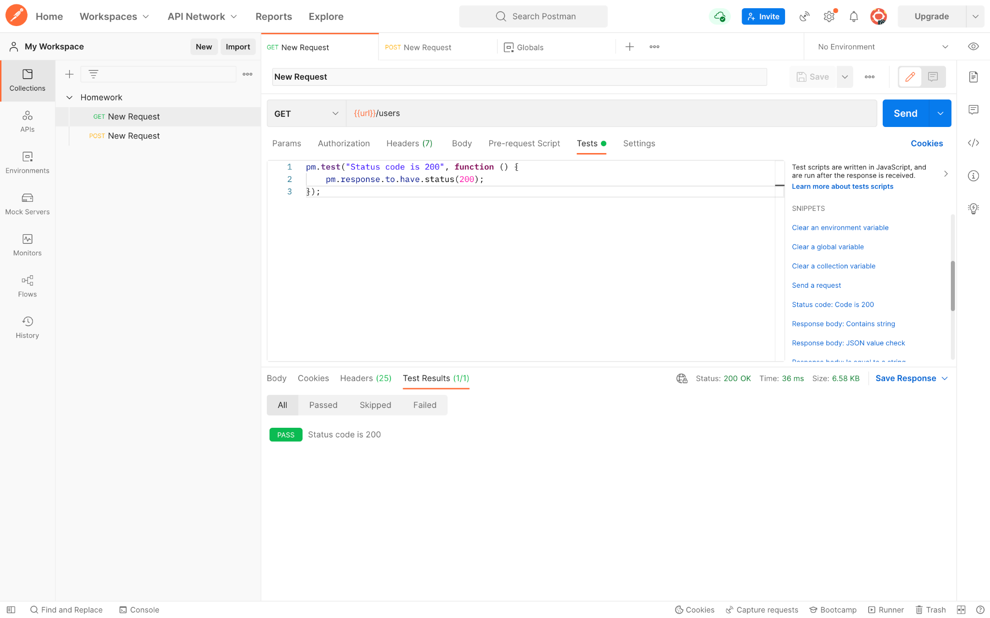

1. Go to runner
2. Add requests to run tests
3. Run tests
4. Check the results → “Pass”

